- SELF INTRO:
Hi this is name from place. Am working as a Test engineer in xxxxxxxx Technologies. I have 2 years of experience in testing. My roles and responsibilities are gathering requirement from the SRS, Writing Test Cases based on the requirement , Executing the test cases, preparing bug reports, Tracking defects and updating the status in RTM. I have involved in 2 projects. My current project is banking, and i have involved in Functionality Testing and Integration Testing. Currently am working with Integration testing.
- ROLES AND RESPONSIBILITIES:
- Gathering Requirement From The SRS
- Writing Test Cases Based On The Requirement
- Executing The Test Cases
- Preparing Bug Reports
- Tracking Defects
- Updating The Status In RTM.
- TESTING TYPES OR TEST STEATEGY:
FUNCTIONALITY TESTING SCENARIO: (Checking the Behaviour of the application) In my FUND TRANSFER module i have scenario called OWN ACCOUNT TRANSFER. In that we have to check whether the fund is transferred from one account to the same person’s account. So we have to fill the fields like from, To, Amount, Date, and Time, Description then click Go button. It will move to verification screen there we can check the given details and if it is correct we have to give transaction password and click Go button, now the fund have to transfer and the Confirmation message should display. This is functionality scenario.
INTEGRATION SCENARIO: (Changes made in one module reflects in the same module or in the other module) in my FUND TRANSFER Module if am doing own account transfer then the amount should be reduced from the Main module named ACCOUNTS. This is integration scenario.
REGRESSION TESTING SCENARIO: (Checking the changes and the impact of the change in other modules is called regression)
- EXPLAIN SDLC:
It has 5 phases
- Planning
- Designing
- Coding
- Testing
- Implementation and maintenance
- In planning phase they (PM & SME) will gather the requirements from the client based on that cost estimation will be done. Then task allocation, Time schedule, Environmental setup(Analyst), Document preparation (BRS- by SME, FRS- by Technical Writer) all these things will be done.
- In designing phase they(S/w architect-Front End, DBA-Back End) will design the Front end and Back end.
- In coding phase they (developer) will develop the project by writing code.
- In Testing using the V Model we will involve is Testing Life Cycle. We will test the project by writing test cases, executing it, preparing bug report and involve in defect tracking process.
- In last phase they (Maintenance team) will install the software in client place and also they will support them during guarantee or warrantee period.
- EXPLAIN STLC:
- In STLC Our Test Manager And TL Will Gather Requirement From The SRS Document.
- After That TL Will Prepare Test Plan Document. After The Test Plan Get Freeze, We Will Get SRS And Test Plan.
- By Gathering Requirement From The SRS We Will Write Test Case For The Given Module.
- Then We Will Send It To TL For Reviewing Process
- After Getting Approval For Test Cases We Will Prepare Test Data
- Then Using The Executable Files We Will Execute The Test Cases.
- If We Rae Getting Any Defects We Will Prepare Bug Report And Forward It To Developers,
- They Will Fix It And We Have To Retest It And Close. Finally After Fixing Maximum Of Bug We Will Release The Project.
- Then TL Or Our Sr. Test Engineer Will Prepare Test Summary Report.
- DAILY ACTIVITIES OF TEST ENGINEER:
Login to office, checking mails, If any work assigned for that particular day i will do that first or else i will do my assigned work, I will write Test Cases, Get Approval from TL, Execute the Test cases, Involve in defect tracking, attend review meeting, Bug Review meeting, Team Meeting, Catch Up meeting in the scheduled day and Time.
- PEOPLE INVOLVING IN MEETINGS:
REVIEW MEETING:- (Monthly Once- Discussion about project, new updation, Status of the project) Whole Testing team, TL, Test Manager, Project Manager, SME
BUG REVIEW MEETING:- (whenever major bug comes- Discussion about major Bugs) Project manager, SME, Test Manager, TL Particular Developers and Test Engineer who raised Bug.
TEAM MEETING:- (weekly once) Discussion about Work schedule and status of the Testing Process) All the Team Members in Our Team.
CATCH UP MEETING:- (Daily at evening – To report daily activities and to get next day Plan and schedule) All Members in Our Team.

- BUG LIFE CYCLE OR DEFECT TRACKING PROCESS:
- Once I got the bug I will prepare Bug Report in QC tool and forward that to the Development TL.
- He will check with the SRS and Open the Bug.
- Then he will assign it to the developer.
- Then the developer will fix it and resend it to me for retesting.
- I will do Retesting and Regression if needed.
- Then if it is working properly i will close it otherwise i will reopen it.
- If the bug is not specified in the SRS the Devl. TL will Reject it or if the priority and severity is low and also the build release is nearer means they will defer (Postponing) the bug to next build.
- BE PREPARED WITH THE FOLLOWING:
TOTAL NO OF TEST CASES FOR EACH AND EVERY PROJECT?
TOTAL NO OF TEST CASES FOR FUNCTIONALITY TESTING?
TOTAL NO OF TEST CASES FOR INTEGRATION TESTING?
TOTAL NO OF TEST CASES FOR REGRESSION TESTING?
TOTAL NO OF BUGS FOUND?
TOTAL NO OF HIGH PRIORITY BUGS?
TOTAL NO OF LOW PRIORITY BUGS?
TOTAL NO OF MEDIUM PRIORITY BUGS?
TOTAL NO OF HIGH SEVERITY BUGS?
TOTAL NO OF LOW SEVERITY BUGS?
TOTAL NO OF MEDIUM SEVERITY BUGS?
Note:
- You will write 50 to 60 Test cases per day.
- Working hours- 8 hr
- Break- 1 hr
- Working day per week – 5 Days
- Leave Saturday Sunday and Public Holidays then calculate no of working days in each month.
- Based on that take the total count of the Test Cases.
- You will take 60% of days to write Test Cases 40% of days to execute the Test Cases and Track Defects. So calculate No. Of Test Case accordingly.
- HOW TO TRACK DEFECTS USING QC.
QC version 9.2, It is the Product of HP, It is a Test Management Tool, It Contains five Modules.
They are:
 Release: To specify the Release details about the Project.
 Requirements: To Trace the Requirements.
 Test Plan: To write Test Case and to Import Test Case form Excel Sheet.
 Test Lab: To Execute Test Cases and to change the status of the bug manually (status- No Run, Pass, Fail).
 Defects: To Track Defect. This is the mail module in QC.
You will use QC only for Defect Tracking. You have to click new defects option so you will get a screen which contains the fields such as summary, category etc... 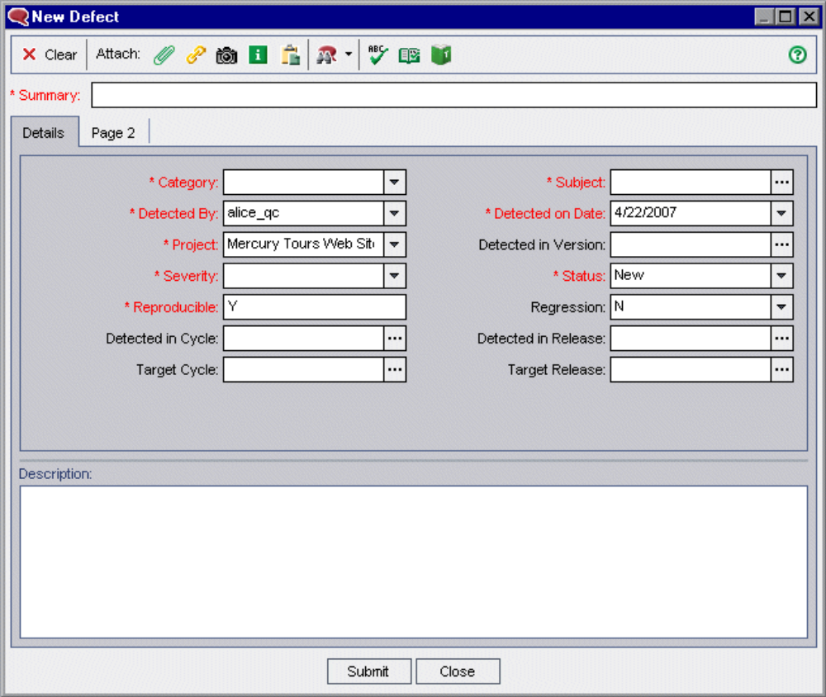
In this screen you will put the status as new. Then you will check for the similar defects. For that you will use filter option  so all the similar bugs will be displayed as follows
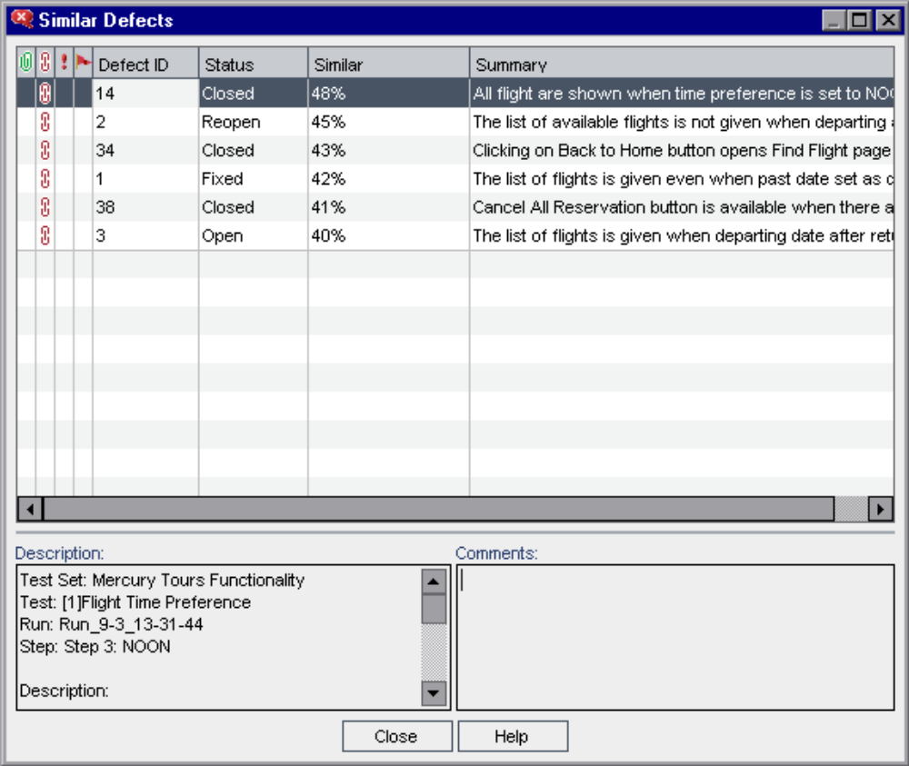
If your defect is diferrent from the lis given you have to edit the defect and you need to send it to the developer. If your defect is already in the list just leave it.
If your defect if different you have to use edit option  to send it to devl TL. So you get following screen.
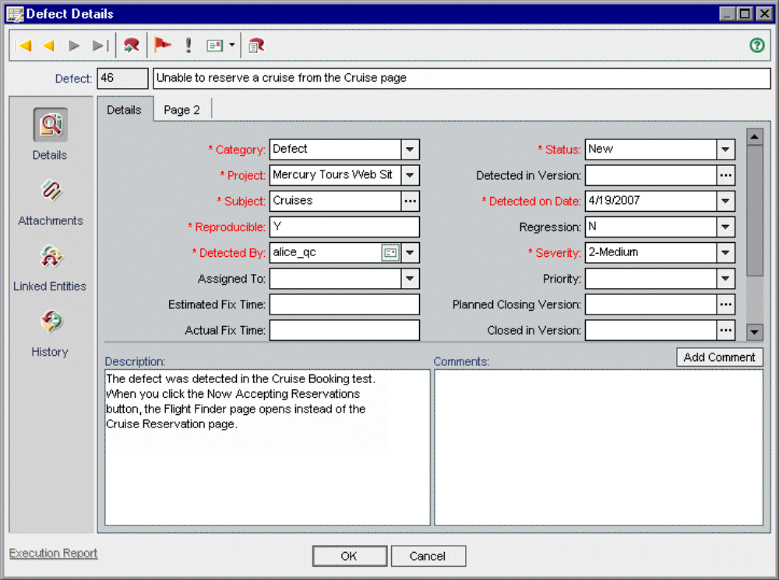
You have to fill all the details in this and by attaching screen shot you can click OK. In assign To you need to give your developer TL’s mail Id then you have to clik ok, so mail will send to devl intimating that a bug is there. Then he will login to QC to see the details of bug. After that he will assign and Fix. Again he will send it to you for retesting.

